Accommodation

To fulfil your accommodation preferences, the IMSSc is working with a range of hotels located at the heart of Belfast city centre within walking distance from school venue. The hotel booking, and the payment should be done only after acceptance to the course. The acceptance will be announced approximately 2 weeks after the application deadline 8th February 2022. The prospective attendees are responsible for hotel booking and payment. When booking the accommodation with any of these hotels, please quote IMSS2022.

Easy Hotel

Easy Hotel is located in the city centre within sight of City Hall. We are less than 5 minutes’ walk from Belfast’s main transport hub at the Europa Bus & Train Centre. Rooms are compact and offer simple comfort at a budget price over 3 floors. All rooms have their own shower & w.c. Easy Hotel has Double, Triple, Accessible & Family Rooms

Accommodation fees: Accommodation will be paid directly to Easy Hotel. For more information on the rooms and prices please visit www.easyHotel.com. More discounts are sometimes available if you register for the Easy Hotel App.

Price per person
Please note these prices are indicative only. Easy Hotel operates like the budget airlines and the price goes up and down. Generally, the earlier you book the cheaper the room. Breakfast is available however it is not included in the room rate to allow guests to only pay for the breakfast they want on the days they want it.

Double room (1 double bed) - £280 for 5 nights (approx. £28/person/night)
Twin Room (2 single beds) - £340 for 5 nights (approx. £34/person/night)

Accommodation in Easy Hotel is on first come first served basis. A limited number of beds have been reserved. Accommodation is available at Easy Hotel until all rooms are booked.

Confirmation and Payment
All bookings are currently flexible due to the current pandemic. The balance will be charged at 12pm on the day of arrival with a £1.00 deposit taken at the time of booking, 100% refundable if you cancel by 12pm on the day of arrival.

Double Room Twin Room
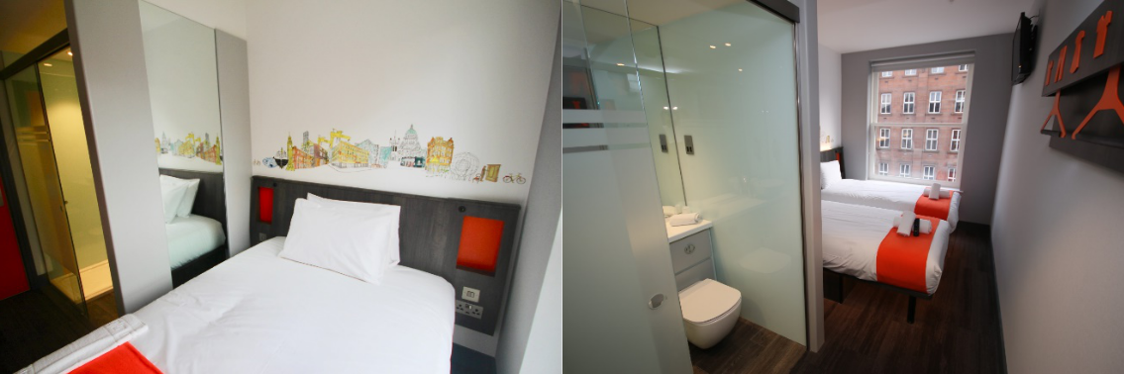
Ibis Budget Etap Hotel Belfast

This ibis budget is located in the heart of Belfast city centre near the Central Train Station, offering essential comfort with modest prices. There are 146 Cocoon rooms for up to three people which all feature en-suite bathrooms and a flat-screen TV. All rooms are 100% non-smoking. There is free Wi-Fi throughout the hotel and the reception is open 24/7.

Accommodation fees: Accommodation will be paid directly to Ibis Budget Etap Hotel Belfast. Rates are per room per night and include of “all you can eat” continental buffet breakfast, and a Wi-Fi:

Single
Twin
Double

Triple

£55.50
£62.00 (twin room can be two single beds or double/bunk bed)
£62.00

£88.50 (double bed and a bunk bed)

Accommodation in Ibis Budget Etap Hotel Belfast is on first come first served basis. A limited number of beds have been reserved. Accommodation is available at Ibis Budget Etap Hotel Belfast until all rooms are booked. To proceed with booking please email Ibis Budget Etap Belfast directly at H7186-AM@accor.com or via website at https://all.accor.com/hotel/7186/index.en.shtml?utm_campaign=seo+maps&utm_medium=se o+maps&utm_source=google+Maps

Confirmation and Payment
On July 26th, the total amount of the room will be charged by the hotel into the given credit card. In case of cancellation after July 26th, no refund will be done.
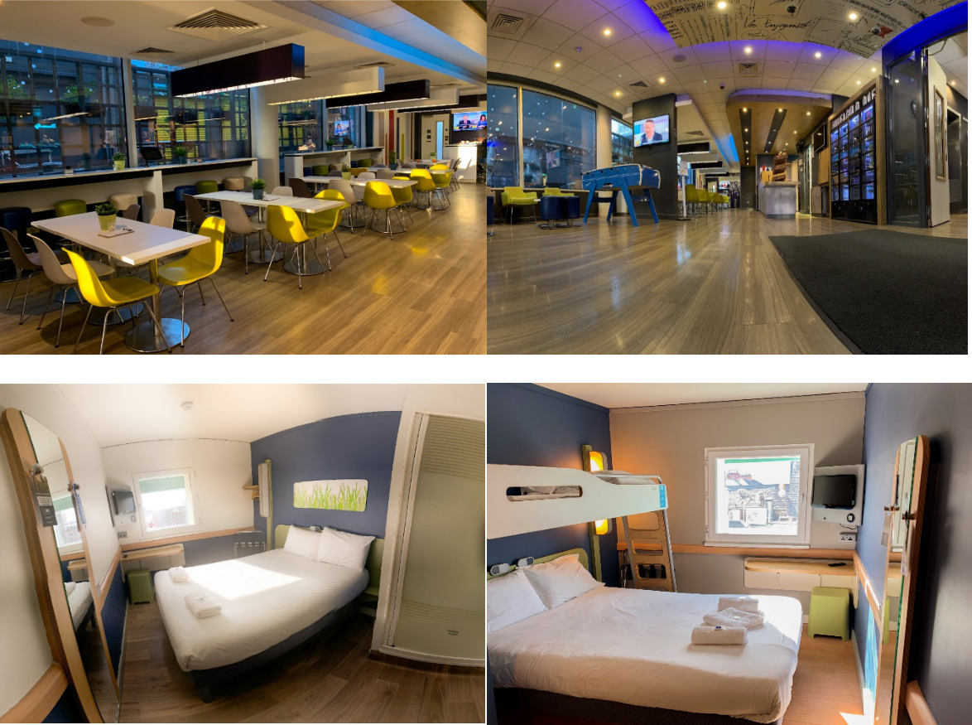

Holliday Inn Belfast 3* and 4* options

The 3- star Holiday Inn Express Belfast Queens Quarter is situated in the University Quarter of the city. This modern hotel has recently been refurbished offering a stylish and contemporary fully remodeled lobby area, with an integrated dining and bar space. Designed to offer zones that guests can use to relax, work or socialize in, along with newly remodeled contemporary 4th generation bedrooms, fast free WIFI and a range of conference rooms. All Holiday Inn Express bedrooms offer comfortable and contemporary accommodation with tea and coffee facilities, a work desk and multi-channel TV

Accommodation fees
B&B for single | £70.00
B&B double occupancy | £75.00

Rates are per room per night and inclusive of service charges, VAT and breakfast.

Terms and conditions:
Rates are non-commissionable and available when booking directly with the hotel.

The rooms will be subject to a 4-week cancellation and full pre-payment policy; ie: 16th July 2021. Payment can be made by bank transfer (Sender must settle any transfer fees) or credit/debit card. All rooms not confirmed by 16th July 2021 will be released and will be available on request. Cancellations made after 16th July 2021 will be non-refundable.

For full hotel information and booking please visit www.hiexpressbelfast.com
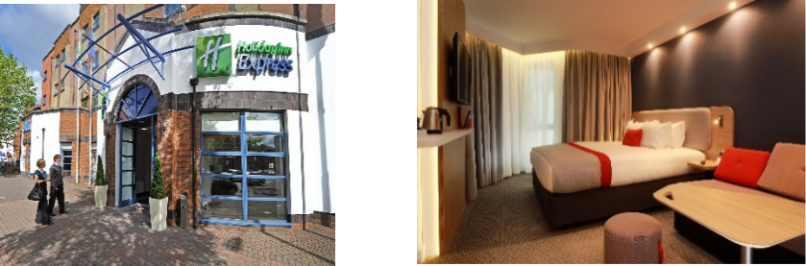

The 4-star Holiday Inn is a full-service hotel with an A La Carte restaurant, The Oakwood Grill, a lounge bar with Starbucks Coffee dock and 24-hour room service for meals and drinks. We provide a 24-hour reception and a gym, a meeting room and free fast Wi-Fi throughout. Centrally located in the heart of the city, Holiday Inn Belfast City Centre is adjacent to the city’s main public transport interchange at Great Victoria Street and close to the main road and motorway network. Secure 24-hour parking is available opposite the hotel at a discounted rate for hotel guests.

Accommodation fees

B&B for single £90.00
B&B double occupancy £95.00

For full hotel information and booking please visit www.hibelfastcitycentre.co.uk
